**Assignment 3**

**Part I**

SELECT * FROM legally_operating_businesses

*🡪Basic command where all rows and columns appear*

SELECT * FROM legally_operating_businesses

WHERE address_city = 'New York'

*🡪 Identify the legally operating businesses in Manhattan*

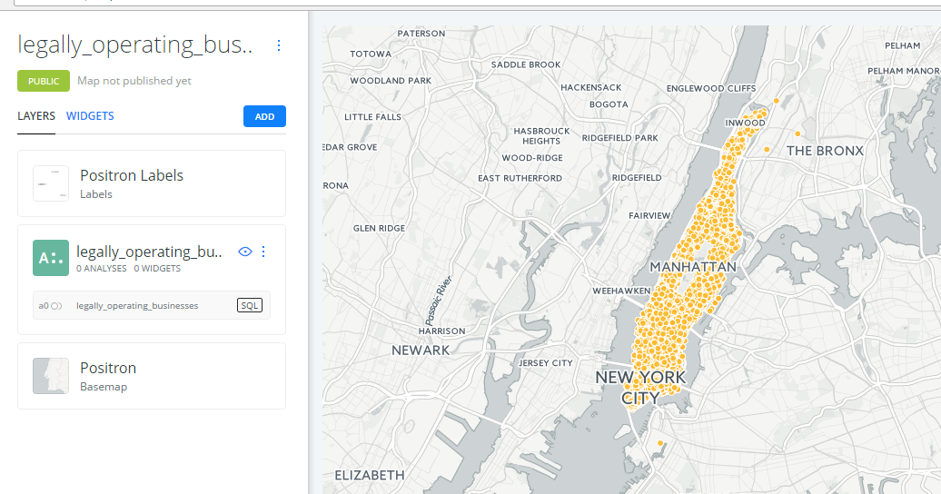

SELECT COUNT(*)

FROM legally_operating_businesses

*🡪 Identify the number of legally operating businesses in all of New York City*

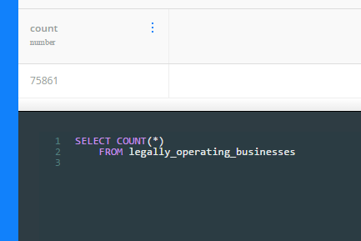

SELECT COUNT(*)

FROM legally_operating_businesses

WHERE address_city= 'New York'

*🡪 Identify the number of legally operating businesses in Manhattan*

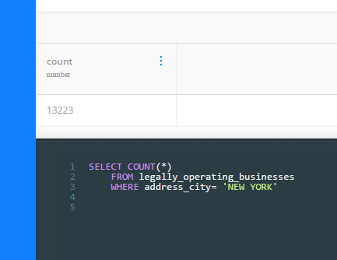

SELECT COUNT(*)

FROM legally_operating_businesses

WHERE license_type= 'Individual'

*🡪 Determine the number of legally operating businesses in Manhattan that hold an individual operating license (rather than business)*

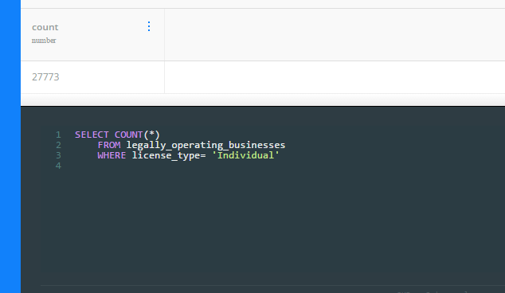

SELECT COUNT(*)

FROM legally_operating_businesses

WHERE license_type= 'business'

*🡪 Determine the number of legally operating businesses in Manhattan that hold a business operating license, and ensure that this plus individual equal the total (to see if there are any missing values)*

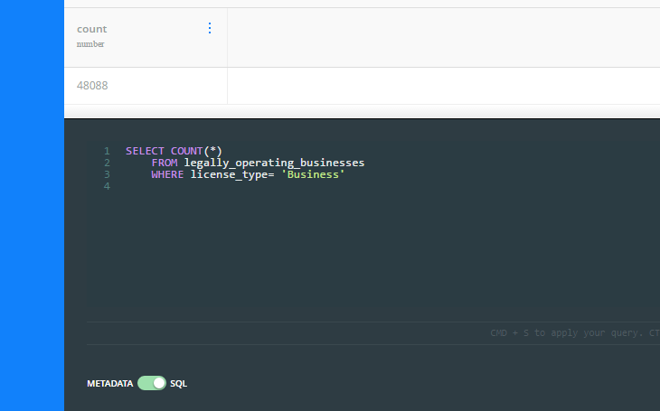

SELECT address_city, COUNT(*)

FROM legally_operating_businesses

GROUP BY address_city

*🡪 Categorize by address_city, or the specific area in which the licenses are held, and generate a list of how many are within each specific area of New York (regardless of business or individual)*

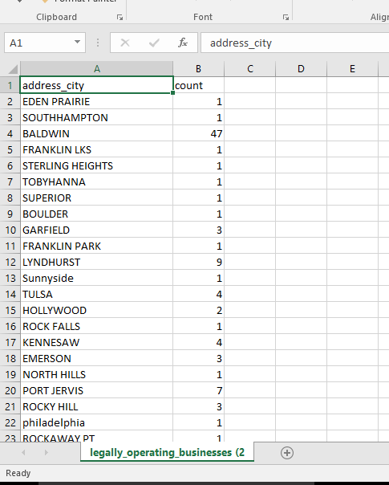

**Part II**

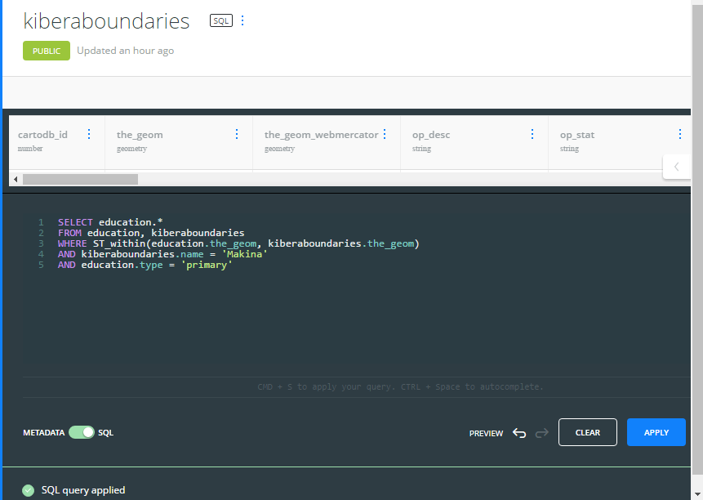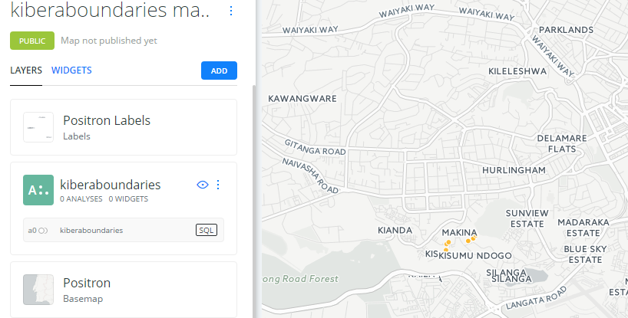

**Part III**

Nursery Schools in the Kibera region. The schools have been discovered by intersecting the Kibera boundaries with the education, and selecting only nursery schools. The results are below with the Carto CSS results.

<https://bm8993.carto.com/builder/98ed4292-f95e-11e6-a455-0e05a8b3e3d7/embed>

